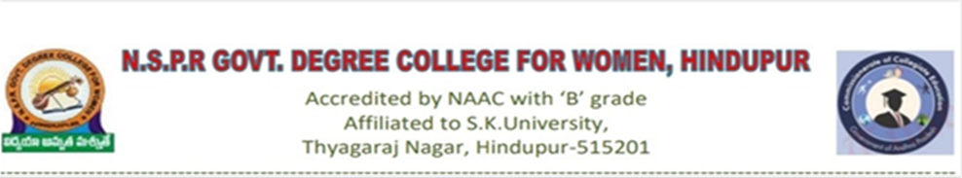 **DEPARTMENT OF ZOOLOGY**

**BEST PRACTICES**

**DEGREE STUDENTS AS PEER TEACHERS: EMPOWERING EDUCATION**

**OBJECTIVES:** Empowering Education: Utilizing Peer Teaching to Enhance Learning in Village Schools.

The objective of implementing peer teaching in village schools by degree students is to foster a collaborative learning environment that empowers both the student-teachers and their peers. Through this practice, degree students can gain valuable teaching experience while providing support and mentorship to younger students in their community. The aim is to enhance academic understanding, critical thinking skills, and self-confidence among all participants, ultimately contributing to the overall improvement of education quality in rural areas. Additionally, peer teaching aims to promote a sense of responsibility, leadership, and community engagement among degree students, preparing them for future roles as educators and leaders in their communities.

**THE CONTEXT:**In rural village schools, access to qualified teachers and educational resources can be limited. Degree students, often from nearby communities, possess valuable knowledge and skills that can be leveraged to support younger students. Peer teaching serves as a means to address this educational gap by fostering a collaborative learning environment within the community. By engaging degree students as peer teachers, the practice aims to improve academic outcomes and empower both the student-teachers and their peers. This initiative not only enhances the quality ofeducation butalso,students thereby contributing to the overall development of rural education. cultivates a sense of responsibility and leadership among degree students, there by contributing to the overall development of rural education.

**THE PRACTICE: ItsContext in Higher Education**

In Indian higher education, particularly in rural areas, there is often a shortage of qualified teachers and resources. Many degree students in colleges and universities come from similar backgrounds as those in nearby villages. Leveraging the knowledge and skills of these degree students to engage in peer teaching can address educational disparities.

By implementing peer teaching initiatives, Indian higher education institutions aim to create a collaborative learning environment where degree students serve as mentors and tutors for their peers in village schools. This not only enhances the academic performance of students in rural areas but also provides valuable teaching experience and leadership opportunities for degree students, contributing to the overall improvement of education quality in India's rural communities.

**EVIDENCE OF SUCCESS:**Peer teaching enhanced the teaching and leadership skills, among students it developed confidence levels, and leadership abilities through self - assessment tools can provide evidence of their growth and success in fulfilling their roles.

Students who participated in peer teaching initiatives can reveal the lasting benefits of the experience, such as higher rates of graduation, employment, or continued involvement in educational initiatives.

**NOTES:**To implement peer teaching effectively in Indian higher education, it's essential to start with a comprehensive needs assessment to understand the specific challenges and opportunities in rural areas. Provide rigorous training to selected degree students, equipping them with teaching skills and resources. Establish partnerships with local schools and communities to ensure support and alignment with existing educational goals. Implement a structured plan for peer teaching sessions, monitor progress, and collect feedback for continuous improvement. Emphasize sustainability by integrating peer teaching into institutional policies and practices.

Through these steps, peer teaching can becomea valuable tool for improving education outcomes and empowering both degree students and their peers in Indian rural communities.

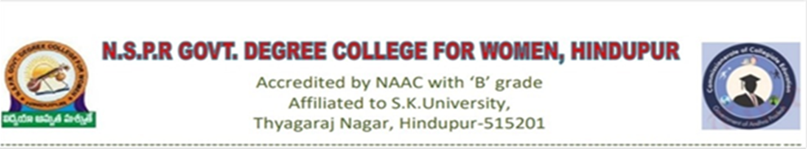

**DEPARTMENT OF ZOOLOGY**

**BEST PRACTICES**

**EXPLORING SCIENCE :EXHIBITING SPECIMENS FOR NON SCIENCE LEARNERS**

**OBJECTIVE** :The objective of exhibiting specimens for non-science learners is to present real-world examples in an accessible and engaging manner, the practice aims to demystify science and inspire curiosity among students from diverse backgrounds. Additionally, it seeks to develop observational skills, critical thinking, and an awareness of the natural world. Through interactive exhibits and immersive experiences, the objective is to cultivate a deeper understanding of the interconnectedness of science and everyday life among non-science learners.

**Context:** In classrooms and educational centers, showing real objects like fossils, animal skeletons, or rocks helps students who are not studying science to understand science better. This practice makes science less confusing and more interesting by letting students see and touch real things. By exploring these objects in interactive displays, students learn about nature and science in a fun and easy way. The goal is to make science enjoyable and to encourage students to want to learn more about the world around them.

**The department of Zoology aims to make science accessible and engaging for non-science learners by showcasing specimens, cultivating Interest, and promoting inclusive learning environments, ultimately inspiring a lifelong appreciation for the natural world.**